TECHNO COMMERCIAL PROPOSAL

Company Name :

Project, Location : Subject :
Date : Quote No :

Kind Attn : Email Id : Contact No :

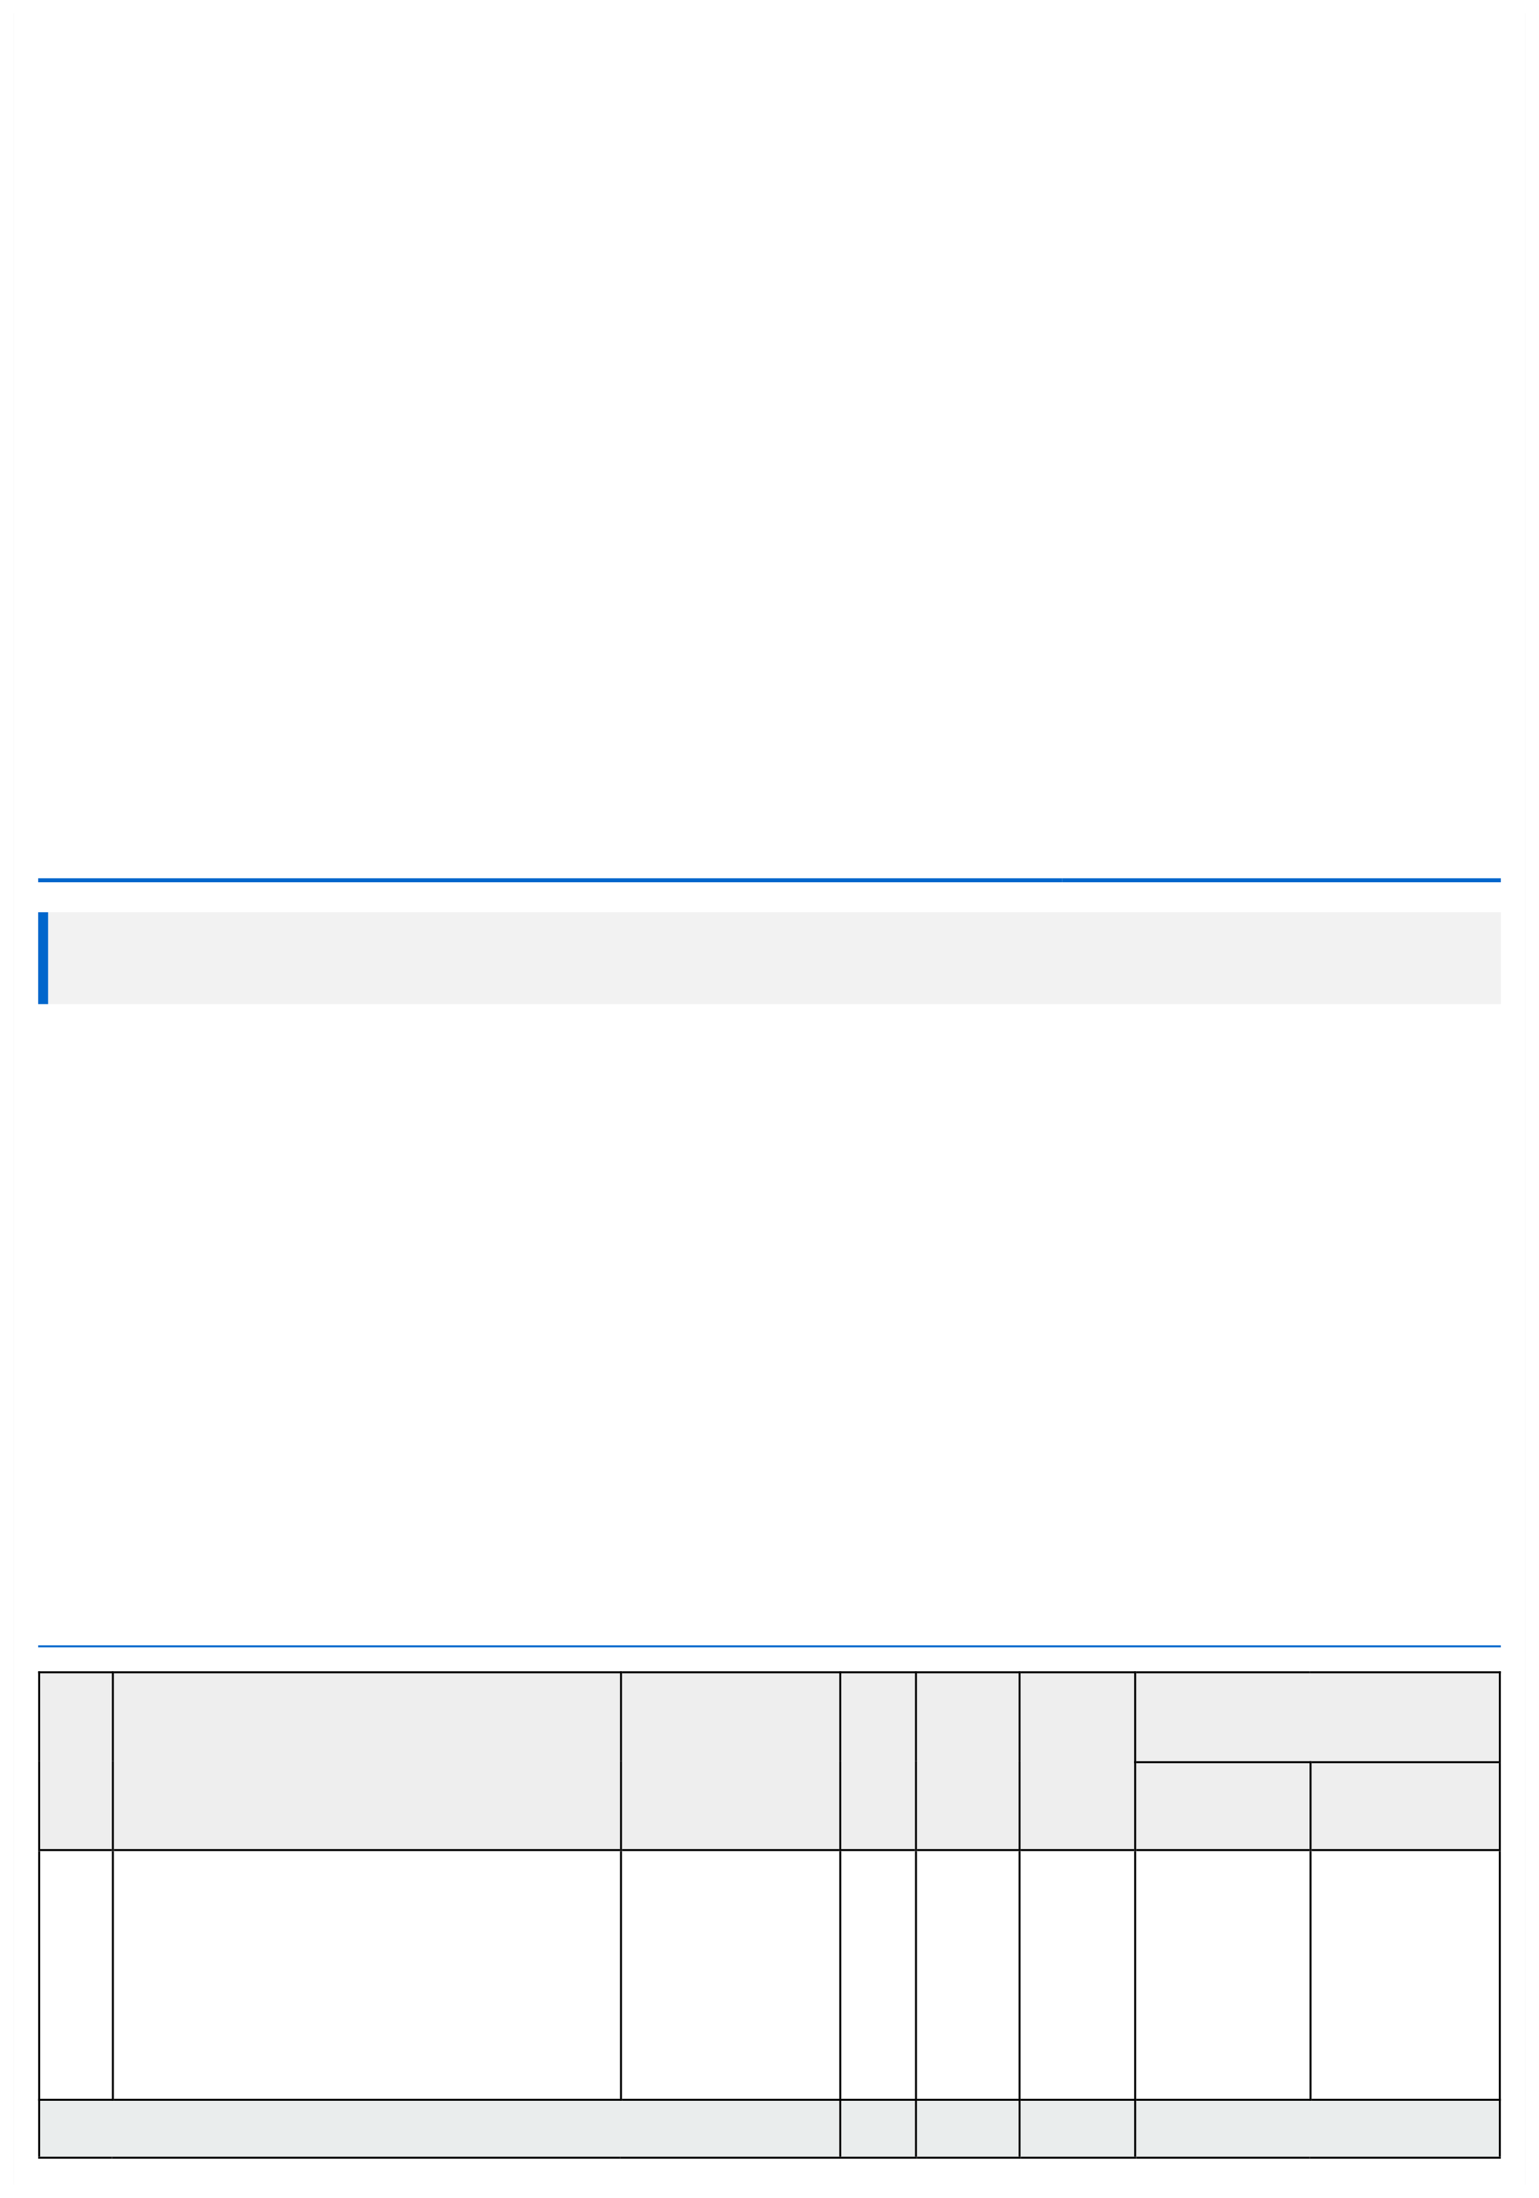


Commercial Proposal

Sr | Description | Size (mm) | Qty | UOM | Tax % | Supply & Installation Charges
No |  |  |  |  |  | in INR

Unit Price (₹) Total Amount
(₹)

1

Total (A)

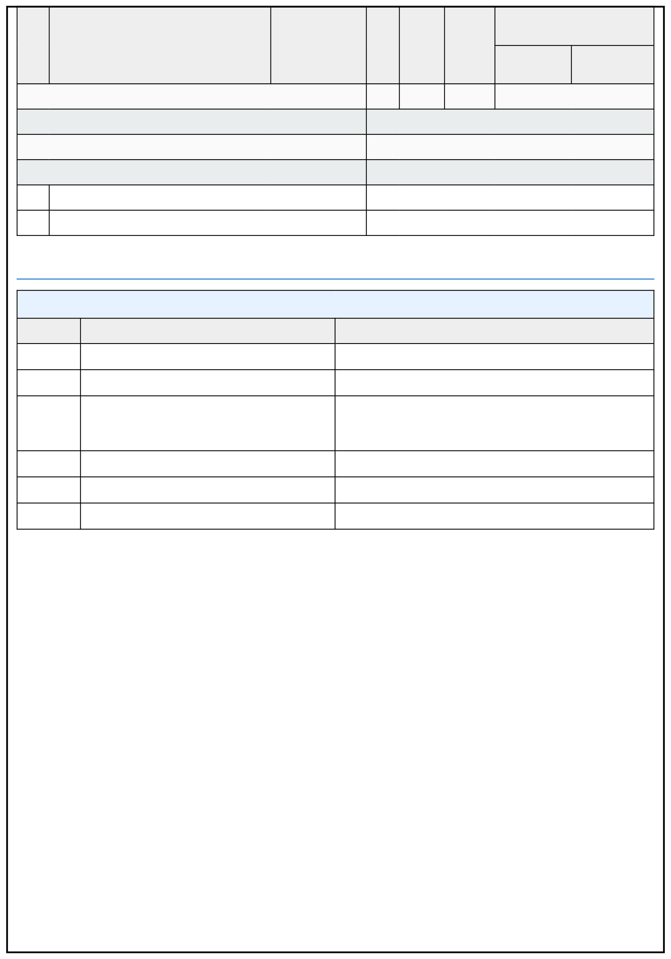
Sr | Description | Size (mm) | Qty | UOM | Tax % | Supply & Installation Charges
No |  |  |  |  |  | in INR

Unit Price (₹) Total Amount
(₹)

P&F Charges on Supply only (B)

Total Without Taxes (A+B)

Total GST

Total With Taxes

  - Transportation Charges

  - Unloading Charges @ Site

Technical Specification

1Sr. No.

2

3

4

5

6

Terms & Conditions

- Price : Ex Works Pune.
- Delivery : 4 - 6 weeks from the date of receipt of confirmed Purchase Order, Advance Payment & Drawing Approval.
- Payment : 80% Advance along with Confirmed Purchase Order. 10% After material Delivery at site.
10% After Installation.
- Validity : Validity of offer is 15 days from the date of quotation.
- Warranty : 12 months from the date of supply. It only covers damage caused due to mechanical system not due to natural calamity.
- Design Clause : COMPANY shall be deemed the authors of their respective concept and drawings with reserved rights, including copyrights. It shall not be used by the owner for future additions or alterations to this Project or for another project or should not copied at any other future project or should not transfer or copied by anyone.
- Compensation Clause : Please note that in the event the buyer cancels an order, after the order is confirmed to us, it is binding to the buyer to pay compensation of 25% of order value.

General Conditions
- Continuous uninterrupted access to installation section or as agreed seperately.
- Provision of 230 V power supply for hand tools.
- A dry and secure area, not in direct sunlight is to be provided for storage of product component
- Access to site between 7 am to 8 pm should be provided.
- Any storage costs for material due to delay outside , will be in client scope.
- The project time indicated does not take into account adverse weather conditions that may prevent safe and efficient working practice. We reserve the right to extend the period accordingly.
- Installation will start after receiving of Site Readiness Photographs or written Email communication.
- We will mobilize the Installation Team in 3 - 4 working days, after reciept of Site Readiness Confirmation.
- For any reason if we need to stop our installation and demobilize the team without completing the work, then extra cost will be applicable for Remobilizing the Team.
- If any change in dimension on actual site, quoted price will affect accordingly which will be in client scope.
- After 1 year warranty, Non comprehensive AMC will be provided at an additional cost.

Note: Please find below List which are in Client Scope

Sr. No
1
Description

Secured and fully covered Store area to keep the material.

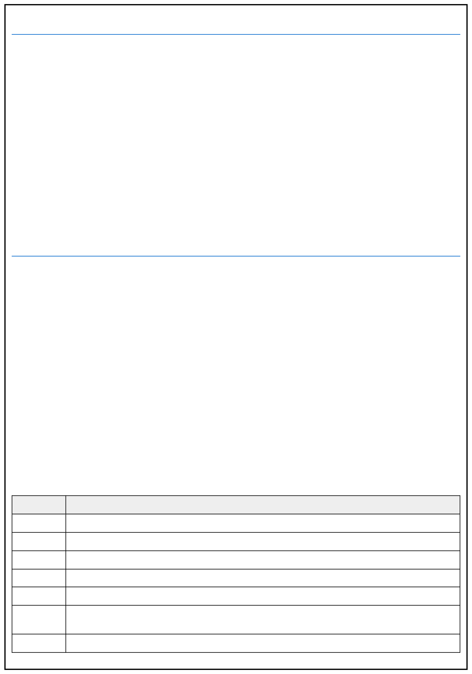
- Scaffolding/Hydra/Crane/Forklift etc - Required for Installation at Site.

- Electrical Supply on the site single phase/three phase points at different places.

- Any civil / masonry/structural work required.

- All structure support required.

- In Case of any changes in the layout as per site requirements after the shipment of material, the additional quantities and wastage.
- Conduits, Cables required


Please feel free to Contact for any further Clarification / Information in this Concern. With Best Regards,
For

Authorized Signatory

Note: This quotation is valid for 15 days from the date of issue.

